

***Capstone Project - Phase A***

***Project Number: 23-1-D-10***

**Supervisor:  
Prof. Zeev Brazily  
zbarzily@braude.ac.il**

**Zohar Barel– 029988995  
zohar.barel@e.braude.ac.il**

**David Blanka – 308553932  
david.blanka@e.braude.ac.il**

**Link to GitHub:**

**https://github.com/DuduBlanka/Give-Us.git**

**Catalog**

**Abstract 3**

**1. Introduction 4**

**1.1. Scope of the project................................................................. 4**

**A great contribution.................................................................. 4**

**A small contribution.................................................................. 5**

**Project’s stakeholder................................................................ 5**

**2. Background and Related work 6**

**2.1 situation today.......................................................................... 6**

**Donation from a large organization.......................................... 6**

**Donation from a small organization.......................................... 6**

**"Azlot Ha'emek" Event hall....................................................... 7**

**"Latt" association..................................................................... 8**

**"Shemo" confectioner.............................................................. 8**

**Private needy (anonymous). 8**

**2.2 Agile Development. 8**

**2.3 Client-Server............................................................................. 9**

**2.4 Cloud computing..................................................................... 10**

**3. Expected Achievements 11**

**3.1. Project goals........................................................................... 11**

**3.2. The uniqueness of the system. 11**

**4. The Process 13**

**4.1. Process 13**

**4.2. Diagrams 14**

**Use-case Diagram.................................................................... 14**

**Class Diagram.......................................................................... 15**

**Activity Diagram...................................................................... 16**

**Software Architecture Diagram 19**

**5. Evaluation/Verification Plan 20**

**6. References 22**

**Abstract**

**Our system, called give-us, ask to prevent food waste and also to try to prevent food insecurity.**

**The system helps large organizations with hundreds of employees as well as event halls to manage their food donations, or can encourage them to start donating their surplus food to associations that provide food to needy.**

**In addition, in our system, even small organizations can donate, such as grocery stores, restaurants, cafes and more.**

**Individuals who need food donations will able to discreetly find donations in their neighborhood and thus be able to their food diverse.**

**Some people cannot afford to buy fruits and vegetables every day.**

**Our system can save large amounts of food thrown away every year, which is estimated at a lot of money.**

# Introduction

## Scope of the project-

**Give us - an application for linking and coordinating donations**

**The system works on 2 levels:**

### A great contribution-

**This is a system that allows large organizations to donate their leftover food.**

**The system simplifies the whole issue of donating food when it connects large organizations such as employers who provide food to their employees and event halls that feed hundreds of invitees per day, to large associations that provide food to hundreds and even more needy people per day.**

**In Israel and also in the world, huge amounts of food are thrown away every day that could have satisfied the food needs of tens of thousands of needy people a day.**

**You can understand the large organizations that don't donate, even though everyone knows that in Israel there are many people who need a hot meal every day and in addition throwing the food causes pollution of the environment, today dealing with food donation is cumbersome, there is no system that brings everything together, it is necessary to hire employees to take care of it, and that Of course, it costs the employer money and also takes time.**

**The system simplifies the entire process of posting the donation, the organization posts the donation in the system and even has the option of donating the donation to a specific organization or freely posting to all the associations, the associations that need these donations to feed hundreds of people a day, will be able to see all available donations in their area of activity and mark the donation and thus ensure the donation is received, this solution allows the association to organize itself since it knows exactly the quantities of food and whether the food needs refrigeration or not, and it can plan a route for collecting donations for that day, thus optimizing the collection of donations and saving time and fuel expenses.**

**Posting the donation in the system is simple and easy, anyone can do it, there is no need to call the associations and ask if they need a donation, just post and the associations will already know that there is food to donate.**

**The system keeps information on the donations of large organizations, whether the donation was collected or thrown away, how many donations were collected, the amount of food donated or thrown away, etc.**

### A small contribution-

**Our system also allows small organizations such as neighborhood grocers, restaurants and cafes to become donors, every day food is thrown away by small organizations in quantities not as large as large organizations, but the accumulation of hundreds of such businesses accumulates to large amounts.**

**But unlike large organizations, yes those in need are private individuals who can look for a donation in their area of residence according to their choice of distance from their home.**

**The details of those in need are not published and there is no way for the small organization to know who the needy is, the needy goes to the place where the donation is and can take according to his wish.**

**Small businesses such as grocers can advertise fresh vegetables and fruits that are left at the end of the day and that the next day will not be suitable for sale instead of throwing them in the trash, restaurants can advertise dishes or surplus food left after the restaurant closes and also cafes, bakeries can donate baked goods left at the end of the day and not bought.**

**This way you can save a lot of surplus food and donate to people who cannot always afford to eat fruits and vegetables.**

**The publication of the donation is done in a simple and efficient way and the search for the donation by the person in need is also done in a simple way.**

**It is possible for the person in need to receive notifications about donations according to the settings he defined.**

### Project’s stakeholder-

**The potential stakeholders of our system are:**

* **Large organizations**
* **Associations**
* **Small organizations**
* **Private needy**

1. **Background and Related work**

**2.1 situation today-**

**Today, there is no system that organizes the entire issue of food donations, both from large and small organizations.**

**From the research we carried out, many problems arose in the whole topic of food donations.**

**Donation from a large organization:**

**Donations are made using old methods where an organization that wants to donate contacts an association by phone and informs it of excess food, sometimes the association does not collect food that day and then the organization has to check with other relevant associations or throw the excess food in the trash.**

**It sometimes happens that associations are the ones who make contact with large organizations, but again the work is cumbersome requiring making telephone calls to dozens of organizations wasting time and manpower.**

**Dealing with the donation causes large organizations to avoid donating food, one can understand the organization that does not always have the time to deal with surplus food every day and find out if there is an association that needs it or not**

**The system simplifies the publication of the donation, it contains many details such as types of food, quantities, whether the food needs refrigeration, whether there is also fresh food added to the donation such as: pastries, vegetables and fruits and the time of food collection.**

**The publication reaches many associations and the organization does not depend on a specific association.**

**From an interview we conducted with a representative of one of the largest nonprofits in Israel, we were told that there is no system that organizes all the donations, and that the organization has to call or go to industrial areas to find out about surplus food, of course this wastes precious time and fuel, even if the nonprofit has organizations that donate to it, it still has to proactively inquire Every day there is surplus food for donation.**

**Using the system will also allow non-profit organizations to receive donations from organizations that did not contribute or had no contact with them, thus increasing the amount of meals provided to those in need.**

**Also, the association will not be dependent on one organization and will have the option of receiving donations from different organizations.**

**Donation from a small organization:**

**Another aspect that emerged from the research we did is that there are many small businesses that throw away fresh food every day that is collected in large quantities during the week.**

**The shortage of time and manpower in small businesses is greater than in large businesses where hundreds of employees work, they have no way to manage their donations, therefore the system gives them a convenient and available solution to advertise small donations of food of any kind to private individuals who live in the vicinity of the business and thus help those in need who are not always can buy fresh food.**

**In an interview we conducted with one of the needy who visited the association we toured, she said that she would be happy if there was a system where she could see food donations in her area of residence, thus she would not waste time or feel uncomfortable asking businesses if they have food to donate, the system would direct them to those A business that has a donation.**

**Sights of people walking around markets or commercial areas looking for food are familiar to all of us, the system can prevent this by posting donations with exact location.**

**Preventing food waste:**

**Every year the news reports about huge amounts of food being thrown away in the past year.**

**For example, in 2021, 2.6 tons of foods worth NIS 21 billion were thrown away in Israel**

**These amounts increase every year when in 2020 2.5 tons of food were thrown away.**

**According to experts, at least half of the amount can be saved, since edible food is thrown away.**

**Apart from the enormous environmental damage caused by the throwing of the food, the thrown food can solve or at least reduce Israel's nutritional problems, since hundreds of thousands of people do not have the ability to provide themselves with a warm aroma or to eat fresh food.**

**"Azlot Ha'emek" Event hall:**

**Large event halls with 3 complexes, hundreds of people are hosted every evening.**

**In a conversation with the owner, he would like to have a system that would centralize all donations, so that it would be possible to publish donations with all the details and to streamline the entire process.**

**Today, the business donates food but not in an orderly manner and many times edible food is thrown away, because no association was found or the association could not come to collect the food and since this requires busy searching many times the business gives up donating and it is thrown away.**

**"Latt" association:**

**An association that provides meals to thousands of people a day and also provides food baskets at a cheap price.**

**The association collects food in many ways but not through an organized system.**

**"Shemo" confectioner:**

**A chain of small neighborhood bakeries that at the end of a business day is left with a lot of excess food that is thrown away many times due to the inability to donate the food in an orderly manner, the manager of the chain agreed that a system in which he could post every day about excess food would help him prevent food from being thrown away on the one hand and on the other hand he would be able to place the food is near the business but not in the business itself, thus people will be able to come without fear of being exposed and it will not interfere with the business's work.**

**Private needy (anonymous):**

**Volunteers in an association and is also in need herself. Agrees, an organized system will help her and people like her to collect food from small businesses without feeling unpleasant and also save time in searching between businesses.**

**2.2 Agile Development-**

**In order to choose the suitable software development methodology, we compare**

**between a couple of development methodologies and we think that is the best**

**methodology for us.**

**Agile working is about bringing people, processes, connectivity and technology, time, and place together to find the most appropriate and effective way of working to carry out a particular task. It is working within guidelines (of the task) but without boundaries (of how you achieve it).**

**Agile software development is an approach in software engineering that assumes**

**that software development is fundamentally an empirical problem, and cannot be**

**solved by methods based on forecasting or design. The term Agile means "agile,**

**light-footed, moving fast and graceful." The approach states that software**

**development is the development of a new product and treats it as a game of**

**goal-oriented collaboration.**

**It encourages flexible responses to change.**

## 2.3 Client-Server-

**Client-server denotes a relationship between cooperating programs in an application, composed of clients initiating requests for services and servers providing that function or service.**

**Clients, also known as service requester, are pieces of computer hardware or server software that request resources and services made available by a server.**

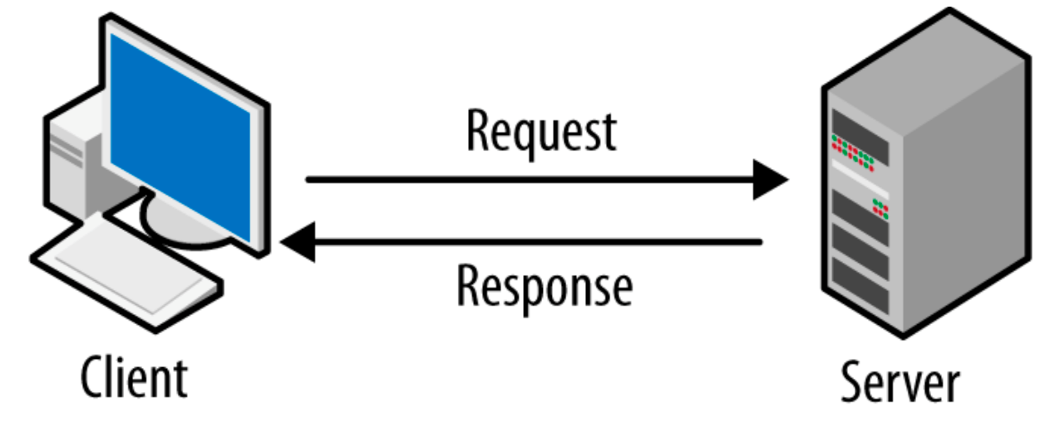**A server is a device or computer program that provides functionality for other devices or programs. Any computerized process that can be used or called upon by a client to share resources and distribute work is a server.**

**What is the Client-Server Model?**  
  
**The client-server model, or client-server architecture, is a distributed application framework dividing tasks between servers and clients, which either reside in the same system or communicate through a computer network or the Internet.  
The client relies on sending a request to another program in order to access a service made available by a server.**

**The server runs one or more programs that share resources with and distribute work among clients.  
The client server relationship communicates in a request–response messaging pattern and must adhere to a common communications protocol, which formally defines the rules, language, and dialog patterns to be used. Client-server communication typically adheres to the TCP/IP protocol suite.   
TCP protocol is the best way to distribute application data into packets that networks can deliver, transfers packets to and receives packets from the network, and manages flow control and transmission of dropped or garbled packets.   
IP is a connection-less protocol in which each packet traveling through the Internet is an independent unit of data unrelated to any other data units.  
Client requests are organized and prioritized in a scheduling system, which helps servers cope in the instance of receiving requests from many distinct clients in a short space of time.  
  
Benefits of Client-Server Computing**

* **A single server hosting all the required data in a single place facilitates easy protection of data and management of user authorization and authentication.**
* **Resources such as network segments, servers, and computers can be added to a client-server network without any significant interruptions.**
* **Data can be accessed efficiently without requiring clients and the server to be in close proximity.**
* **All nodes in the client-server system are independent, requesting data only from the server, which facilitates easy upgrades, replacements, and relocation of the nodes.**

## 2.4 Cloud computing-

**Cloud computing is the delivery of computing services—including servers, storage, databases, networking, software, analytic, and intelligence—over the Internet (“the cloud”) to offer faster innovation, flexible resources, and economies of scale. In order to check our application, we will rent virtual computers that will run our application.**

**3. Expected Achievements**

**3.1. Project goals-**

**The goal is to develop a system that will manage the entire issue of food donations and communicate between donors and donors will make the whole process friendly and simple.**

**To change the whole world of food donations and make more and more organizations, big and small, donors.**

**Allow donations to be posted easily and simply..1**

**. Streamline the donation process by saving time in human resources.2**

**3. Avoid throwing edible food as much as possible.**

**4. Save resources for associations that collect food.**

**5. Allow small businesses to become donors and prevent food waste.**

**6. To allow needy people to collect food discreetly and without the unpleasantness that accompanies it.**

**3.2. The uniqueness of the system-**

**A unique system that connects the donor and the recipient, allows you to receive notifications about donations entered into the system and to search for donations according to filters.**

**Allows every business to be a donor to small businesses as well and allows you to donate directly to needy people in a discreet manner.**

**All system operation is simple, such as posting a donation, setting filters for which donations to receive notifications.**

**Alerts are automatically sent to a large organization when the donation has been marked for collection, thus allowing the organization to track the collection.**

**Option to add collection hours, update donation and distribute it to all associations simply.**

**An association that cannot collect the donation can unmark it and the organization will receive an immediate notification, unlike now that it is necessary to call and update and there is always someone available and then the donation is not collected and may be thrown away.**

**4. The Process**

**4.1.** **Process**

**We created an orderly work plan that covers all the processes, starting with the learning process and progressing through the development process until reaching a final product that matches the system's goals.**

**At first, we had to analyze the problem to be solved. Our first task was to precisely define the problem, in other words, what is the problem that needs to be addressed, who are we developing for, and how important is it to find a solution.**

**To achieve all of the above goals, we conducted a survey with potential stakeholders:**

**Which are the big organizations that want to donate their surplus food, but it takes a lot of time and human resources as well.**

**Associations that have to waste time on the phones and unnecessary trips in order to locate food donations.**

**Small organizations whose amount of food does not justify a donation to non-profit organizations but wish to donate the accumulated excess food at the end of the day but do not have the opportunity to do so.**

**and private individuals in need who want to collect food but find it difficult because of the shame or lack of time to walk around markets and commercial areas for many hours.**

**The next step was to check potential solutions, we had to research the various factors regarding each of the potential solutions, and we checked the advantages and disadvantages relevant to each solution.**

**4.2. Diagrams**

**Use-case Diagram-**

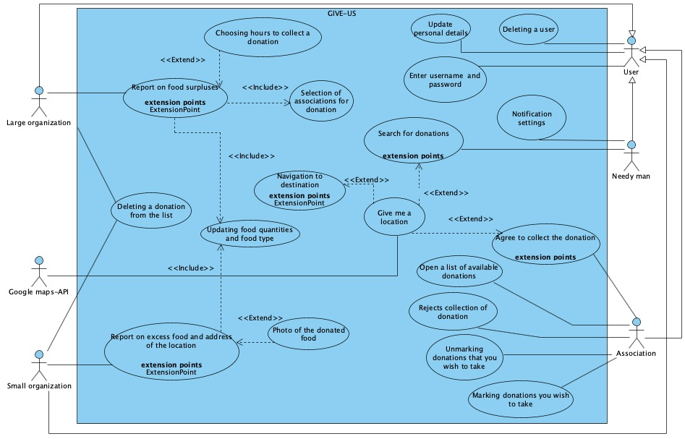

**Fig 1:** Use Case Diagram

**Class Diagram**-

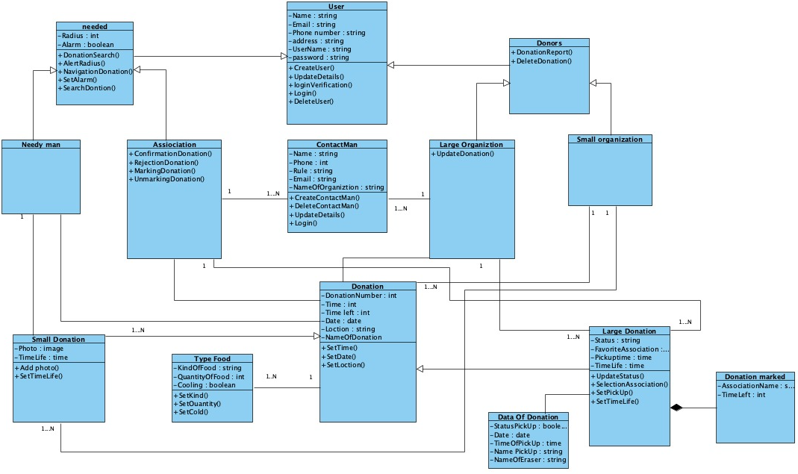

**Fig 2:** Class Diagram

**Activity Diagram-**

**Reporting Big organization**

**Guide of a large donation of a large organization**

1. **The large organization reports a new donation.**
2. **The large organization chooses the type of food and the amount of food.**
3. **If the large organization decides that the food does not require refrigeration then they move to step 5.**
4. **The large organization marks the food that requires refrigeration.**
5. **If the large organization wants to add more food, go back to step 2.**
6. **The system adding a donation to the list.**
7. **If the large organization chooses a favorite association, proceed to step 9.**
8. **The system sends notifications to the relevant associations and finishes the process.**
9. **The large organization chooses a specific association.**
10. **If the association does not approve the donation, return to step 7.**
11. **The association approves the donation.**
12. **The system marking a donation in red - currently unavailable.**
13. **The system sends a notification to the donor - the donation has been marked.**
14. **The system opens a time window for collection**

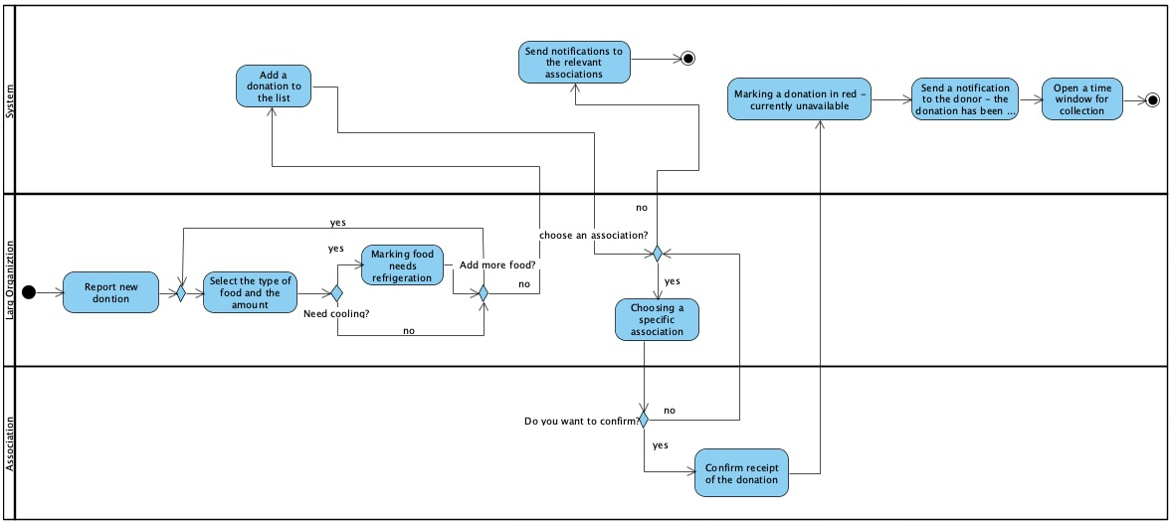

**Fig 3:** large donation of a large organization Activity Diagram

**Reporting Small organization**

**Guide of a small donation of a small organization**

1. **The small organization reports a new donation.**
2. **The small organization chooses the type of food and the amount of food.**
3. **If the small organization chooses to add a photo, it continues to step 5.**
4. **The small organization adds a photo.**
5. **If the small organization wants to add another donation, it returns to step 2.**
6. **The small organization chooses a location to collect the donation.**
7. **If the small organization chooses not to add time, it moves to step 9.**
8. **The small organization adds collection time to the donation data.**
9. **The system Run a life time donation.**
10. **The system adding a donation to the list.**
11. **The system Sending messages to those in need.**

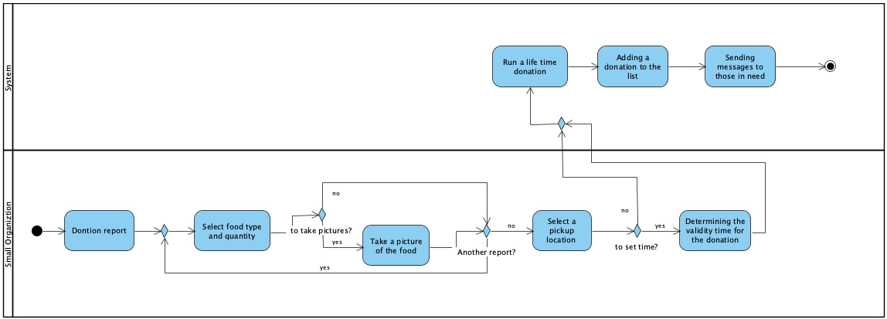

**Fig 4:** small donation of a small organization Activity Diagram

**Search donation**

**guide to finding a donation:**

1. **The association clicks a search button.**
2. **The system displays all available contributions.**
3. **Did you find a relevant contribution? Yes/no**
4. **Yes, Mark the donation. (Jump to number 8).**
5. **No, would you like to do another search? Yes/no**
6. **Yes, return to step 1.**
7. **No, end of donation search.**
8. **The system will mark the donation as unavailable.**
9. **The system will open a time window.**
10. **The system will send a message to the donor about it.**
11. **Would you like to search for another donation? Yes/no**
12. **Yes, return to step 1.**
13. **No, end of donation search.**

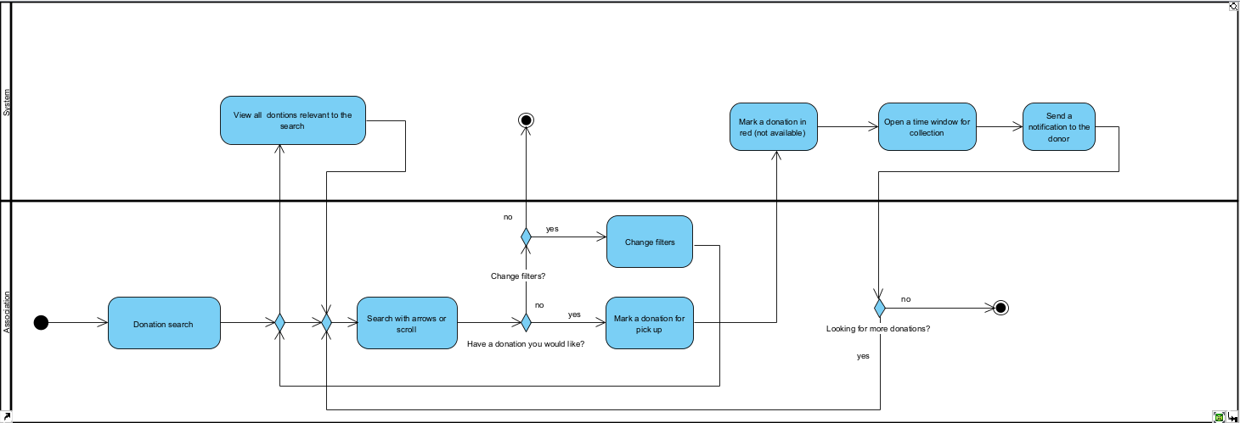

**Fig 5**: Search donation Activity Diagram

### Software Architecture Diagram

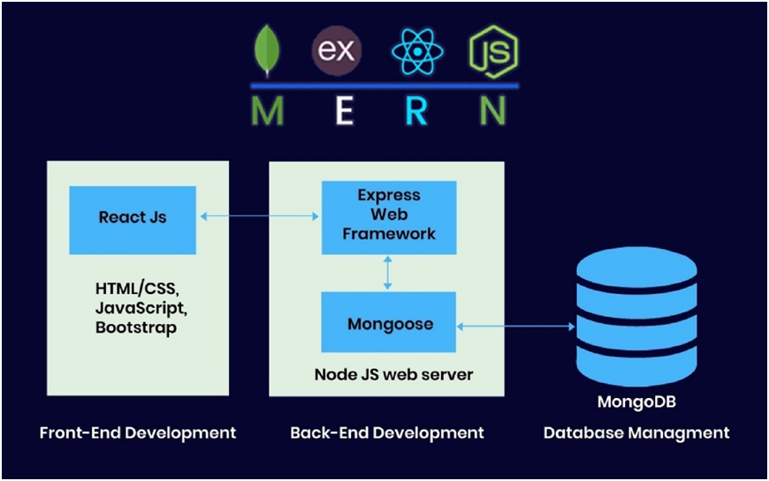

**Fig 6:** Software Architecture Diagram

**4.3. User Interface**

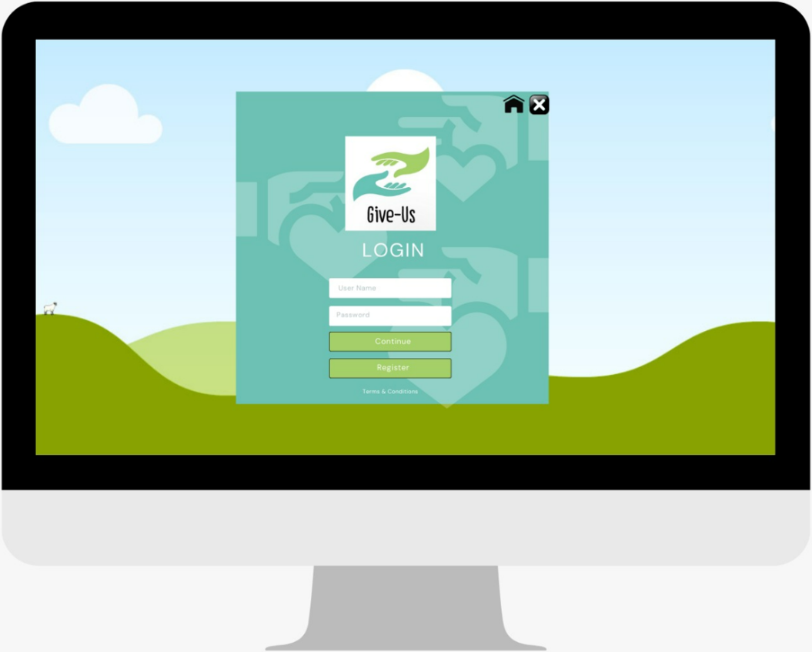 **Login Page:**

**Fig 7:** Login page

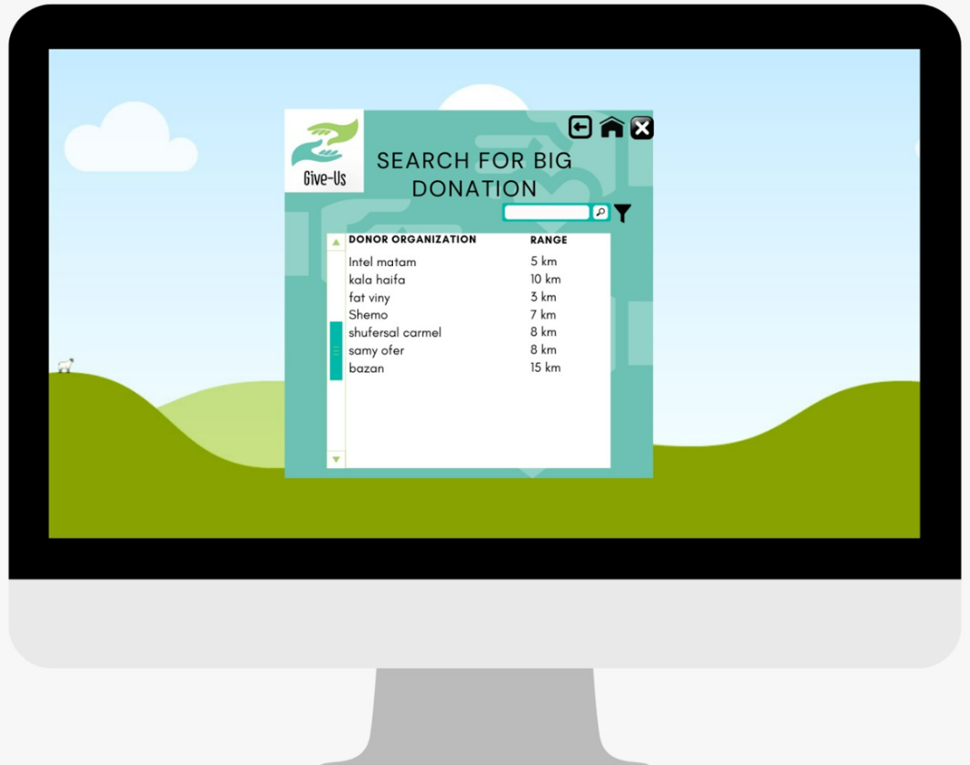**Searching page:**

**Fig 8:** Searching page

**Information on donation page:**

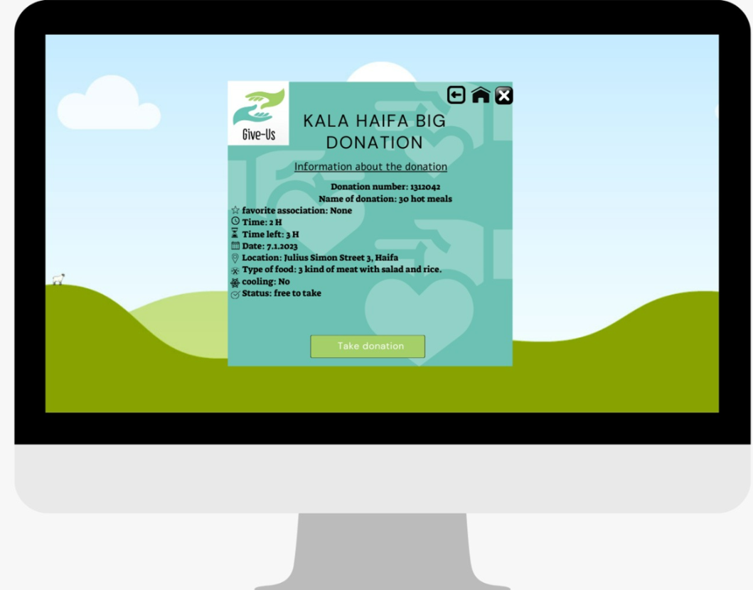

**Fig 9:** Information on donation page page

**5. Evaluation/Verification Plan**

**In order to test our system, we will perform two kinds of evaluation tests.**

|  |  |
| --- | --- |
| **Login** | |
| **Test Subject** | **Expected result** |
| **Username is empty** | **"Enter username" message on the screen** |
| **Empty or incorrect password for username** | **"Wrong password" message on the screen** |
| **Username does not exist** | **"Username does not exist in the system" message on the screen** |
| **User is already logged in** | **"User is already logged in please check" message on the screen** |

|  |  |
| --- | --- |
| **Registration** | |
| **Test Subject** | **Expected result** |
| **Incomplete details** | **"Incomplete details please fill in the one marked with a star" message on the screen and a red mark** |
| **Invalid email** | **"Invalid email" message on the screen and a red mark** |
| **Invalid phone number** | **“Invalid phone number” message on the screen** |
| **Username exists** | **"Username exists" message on the screen** |
| **Email exists** | **"Email is already in use" message on the screen** |
| **Password too weak** | **"Weak password" message on the screen** |
| **Invalid password validation** | **"Password verification does not match" message on the screen** |

|  |  |
| --- | --- |
| **Adding Contact Man** | |
| **Test Subject** | **Expected result** |
| **Incomplete details** | **"Incomplete details please fill in the one marked with a star" message on the screen and a red mark** |
| **Invalid email** | **"Invalid email" message on the screen and a red mark** |
| **Invalid phone number** | **“Invalid phone number” message on the screen** |

|  |  |
| --- | --- |
| **adding donation** | |
| **Test Subject** | **Expected result** |
| **Incomplete details** | **"Donation details incomplete" message on the screen and a red mark** |
| **Incorrect time** | **"Incorrect time" message on the screen** |
| **Incorrect location** | **"Location Incorrect" message on the screen** |
| **Invalid date** | **"Invalid date" message on the screen** |
| **0 types of food have been added** | **"There are currently 0 types of food, please add" message on the screen** |
| **Food details are missing** | **Message "Your donation details are incomplete, please fill in the food details" on the screen** |

|  |  |
| --- | --- |
| **adding small donation** | |
| **Test Subject** | **Expected result** |
| **No image entered** | **"Please enter a picture" message on the screen** |
| **Time life is incorrect** | **"Incorrect time" message on the screen** |

|  |  |
| --- | --- |
| **adding large donation** | |
| **Test Subject** | **Expected result** |
| **Collection time has passed** | **"Collection time has passed, please enter a new time" message on the screen** |
| **Time life is incorrect** | **"Incorrect time" message on the screen** |
| **The name of the favorite association does not exist in the system** | **"The name of the favorite association you selected does not exist in the system" message on the screen** |

# References

**An article in the Calcalist newspaper:**

[**https://www.calcalist.co.il/local_news/article/hkupo000so**](https://www.calcalist.co.il/local_news/article/hkupo000so)